Customer service

process note

Version control:
Document History
Version | Created by | Reviewed | Approved | Created date | Reviewed Date
1 | Rashmi Manjrekar | Anshul Arzare | Anshul Arzare | Aug-18 | Aug-18
1.01 | Rashmi Manjrekar | Fayyaz Millwala | Fayyaz Millwala | Sep-19 | Sep-19
1.02 | Kamal Negi | Fayyaz Millwala | Fayyaz Millwala | Jan-20 | Jan-20
1.03 | Kamal Negi | Fayyaz Millwala | Fayyaz Millwala | Oct-20 | Oct-20
1.04 | Jay Shah | Fayyaz Millwala | Fayyaz Millwala | Apr-21 | Apr-21
1.05 | Jay Shah | Fayyaz Millwala | Fayyaz Millwala | May-21 | May-21
1.06 | Jay Shah | Mithul Gandhi | Anshul Arzare | Apr-23 | May-23
1.07 | Jay Shah | Mithul Gandhi | Anshul Arzare | Dec-23 | Jan-24
1.08 | Anthony Dsouza | Jay Shah | Mithul Gandhi | Feb-25 | Mar-25
1.09 | Anthony Dsouza | Gaganjyot Virk | Viswanath Srinivas Pendyala | Feb-26 | Feb-26

Objective
The objective of this process note is to outline the end-to-end Customer Service (CS) framework in a Bank–Broker model, ensuring:
- Timely and accurate resolution of customer queries and complaints
- Compliance with applicable regulatory requirements (SEBI, Exchanges, RBI where applicable)
- Consistent customer experience across service channels
- Proper escalation, governance, and audit readiness

Scope
This process applies to all customer service interactions related to:
- Wealth Broking services
- Trading, demat, margin, settlement, and account related queries -related queries
- Regulatory complaints and service escalations
Channels covered include:
- Calls
- Emails
- Digital platforms (chat, app, web)
- Branch‑routed service requests
- Customer Service Operating Model
CS function operates under a tiered service delivery model:
- Level 1 (L1): Frontline Associates
- Level 2 (L2): Managers / Senior Managers
- Level 3 (L3): Escalations Team
- Oversight: CS HOD, COO, CBO, MD CEO
- Support Functions: CX, MIS & Communications (merged function)
- Other stakeholders: Sales/Dealing, product team and IT
SOP governance(ß click on the link)

- Channels in Customer Service:
- Emails
- Inbound
- Scores
- Chat
- Social Media
- Walk-in

Process Flow
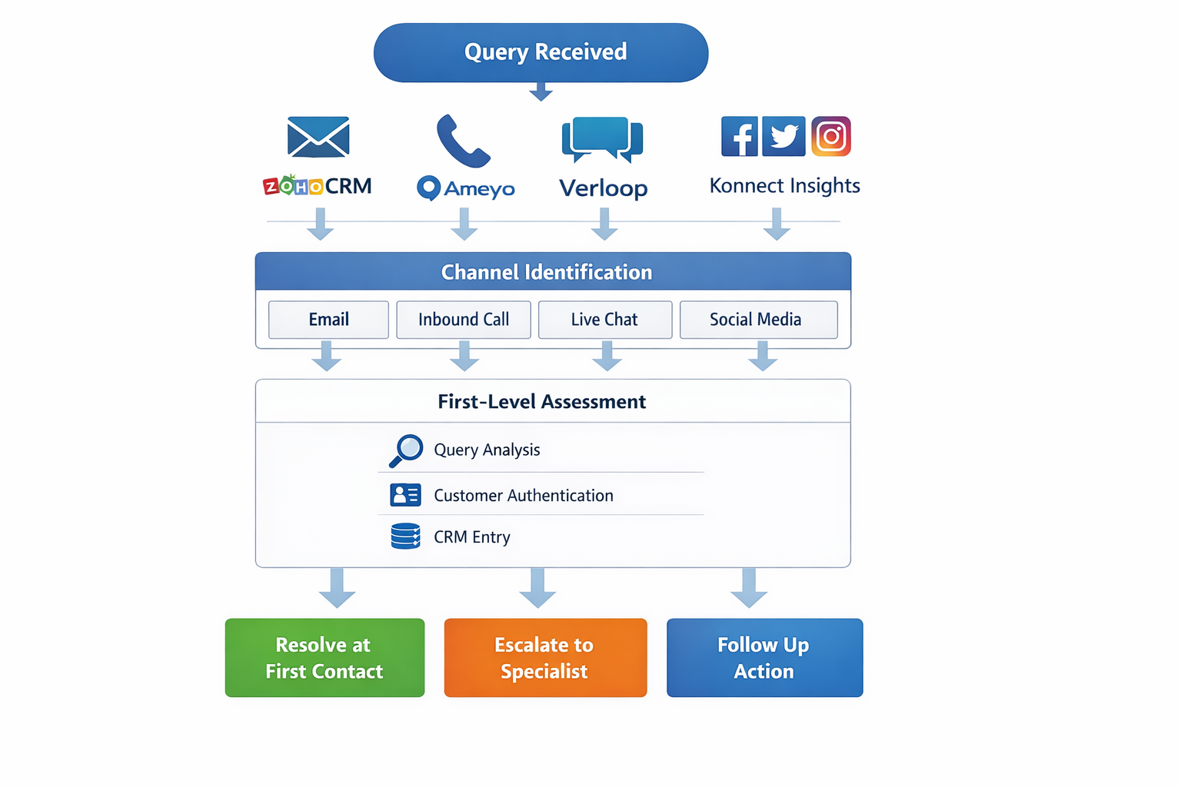

- The processing of customers query complaint or request and Feedback is managed via the following means:

Email (CRM)
All cases received in outlook are logged in CRM as per the ownership of individual desks. The tickets created are based on the primary email received, If the subject line or the email thread (unique reference id) is the same, then the emails are merged in the same ticket until they are marked closed. All new emails can be merged/Split manually by the associated ticket owner depending on the scenario.
Note: if the sender uses the earlier thread to revert to a previous email with a different query, it still merges with an existing open ticket with the same reference id (Parent>Child)
- All cases received in Outlook get tagged Automatically as a ticket on round robin basis to the Associates.
- The associates work on the cases and reply via Zoho within the ticket assigned.
- Query/Complaint received on email, Phone or internally or via the website or other desks are aligned in Zoho or forwarded to the customer.service@ysil.in id for ticket creation.
- Tickets are generated in Zoho and auto replies with Ticket no. acknowledging the email received from the sender is sent.
- Agent tags case as Query/Complaint/request/feedback/Technical issues/Junk as per the defined headers: QRC_tagging file is available on the link
Complaint: An expression of dissatisfaction regarding a product, service, or experience that requires corrective action or resolution.
Request: A customer-initiated requirement for information, service, or assistance that does not involve dissatisfaction.
Query: A question or clarification sought by the customer regarding products, services, or processes, which does not imply dissatisfaction or require corrective action.
Technical Issues: where the customer is unable to access the Website, OMNI app, Stock trader app, whenever there is a system outage declared by product/IT team, or specific to an individual customer.
Feedback: where the customer has provided their logic for the system, or any enhancements that they wish should be a part of the system. (All such feedback is sent to the product team) no further follow-up from the customer service team is required here.
- If there is a complaint received, the case is analyzed for any further Actionable/Approvals and if any identified, then the same is sent to the team concerned.
- Once a revert is received, the agent resolves the complaint and writes back from Zoho to the client/email recipient and closes the ticket.
- Once the ticket is closed, an auto response is generated along with Ticket No. announcing the closure of the complaint and is sent to the customer’s registered email address as received earlier.
- The SOP for different Query categories is on the attached link (Click here), QRC tagging sheet attached here

TAT Master
TAT is now measured as <24hrs or >24hrs,
where the calculation is (Resolved date – Created date *24 =(TAT) is in hrs.)
TAT Calculation:
The data for TAT is extracted from Zoho, under the Analytics tab: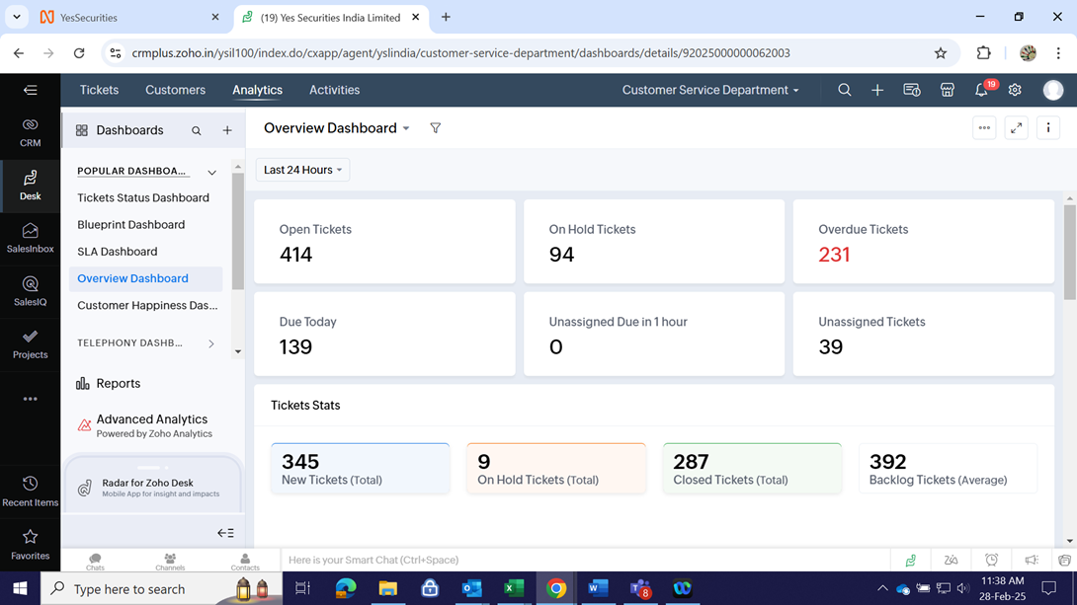
Under the Analytics tab in the Reports section further YSIL REPORTS sub section
We select the Report “Daily contact report_Srini format”, then use the selections available as Filter should be used for the period defined.

Investor Grievance Redressal Mechanism

The Investor Grievance Redressal Mechanism establishes a structured, compliant, and transparent framework for addressing investor and client complaints within the organization. It aligns with SEBI regulations, Stock Exchange and Depository circulars, and SCORES 2.0 guidelines.
Key Objectives:
- Provide timely and transparent resolution of investor issues.
- Define clear responsibilities, escalation levels, and turnaround times.
- Maintain complete documentation and promote continual process improvement.
SOP

Email Feedback
At the closure of a ticket in Zoho, the customer is given the options to rate the interaction, Good; Bad; Ok.
Process: The team leader will analyze all the negative feedback to categorize them under the buckets - Agent feedback, process feedback, or product feedback.
Any case where the agent has not been able to answer the customer basis the SOP set for the relevant query, here agent feedback will be documented.
Cases where there is a process gap according to the customer, however, are not a part of the current process followed in YSL – these cases will be discussed with respective stakeholders for closure decision, and a final draft is shared with the customer. The ownership of the process to be implemented lies with the respective Stakeholder within YSL.
Cases where the feedback is pertinent to a particular product in YSL, mail is sent to the product team with the feedback provided by the customer. The ownership of developing and implementing the product lies with the product team.
Bank Queries/complaints management: SOP

Annexure:
- All SEBI complaints are tagged on Zoho as a ticket only when the email is forwarded by the Compliance team and the ticket is tagged and updated basis the QRC tagging file. The tickets consolidation is done with the compliance team in the trailing month on an email
- All Queries/complaints received from IGC, Compliance team, MD CEO desk, CBO are addressed in Zoho and tagged basis the QRC tagging file.
- In some instances where the UCC is not captured automatically, the UCC of the customers is accurately captured under the UCC field while logging the Complaints/Query/Request/Technical issues/Feedback in the Zoho application. The team ensures that even if its mail is received from any other source or internally and pertains to customer, it is recorded in the system. If the query is not pertaining to a customer, since the UCC cell cannot be altered being numerical only, it is tagged as ‘0’ and non-customer or new to YSL in remarks column in Zoho along with relevant query.

Inbound center (Ameyo + MOS CRM)
Customer calls are attended to via Ameyo and tagged in MOS CRM; all Non-FTR cases are updated in Zoho CRM as a ticket for follow-ups on Issues and complaints. Further developments are planned for the integration of both systems to avoid any spillage.
The inbound team addresses 95% of cases as FTR, and the rest are addressed via the CRM system and call backs in Ameyo.
Three attempts are made to contact unique callers who could not be reached during the day, and the MIS is maintained by the Inbound Team.
All calls are disposed of from Ameyo system based on the outcome of the call.

Mandatory Customer Verification
Calls Received from Unregistered Phone Numbers, (High‑Risk Scenario – Mandatory 2‑Factor Verification)
When a customer calls from a non‑registered mobile number, agents must perform minimum 2 points of verification from the approved list:
- Customer ID / Trading Account ID
- PAN (full or last 4 digits as per policy)
- Date of Birth
- Registered Email ID
- Registered Mobile Number
- Depository Details (DP ID + Client ID)
- Bank account (masked number) – last 4 digits only
- Communication address (partial verification)

Sensitive Data Sharing Restrictions
If the customer requests sensitive information, the agent must:
✔ Send the information only to the registered email ID,
OR
✔ Call back the registered mobile number and share the information after completing verification.
This ensures data privacy and prevents unauthorized disclosure, aligning with SEBI, Depositories, and Information Security guidelines.

Social Media CRM - SOP

Escalation Matrix:
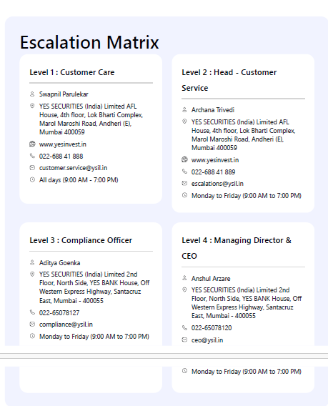
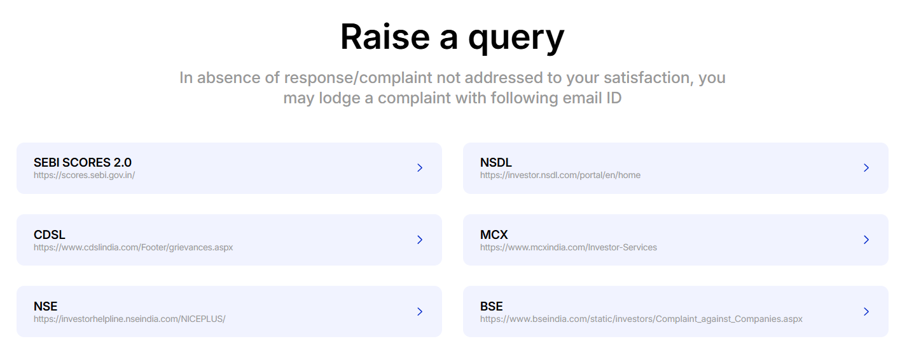

MIS & Reporting
Note: W.E.F 1st July 2025, data is updated daily in a sheet. Meeting with Chief Operating Officer (COO) reviewing the data and assessing improvement areas and path forward. The data obtained from CRM and Ameyo is consolidated on a shared tool Contact report
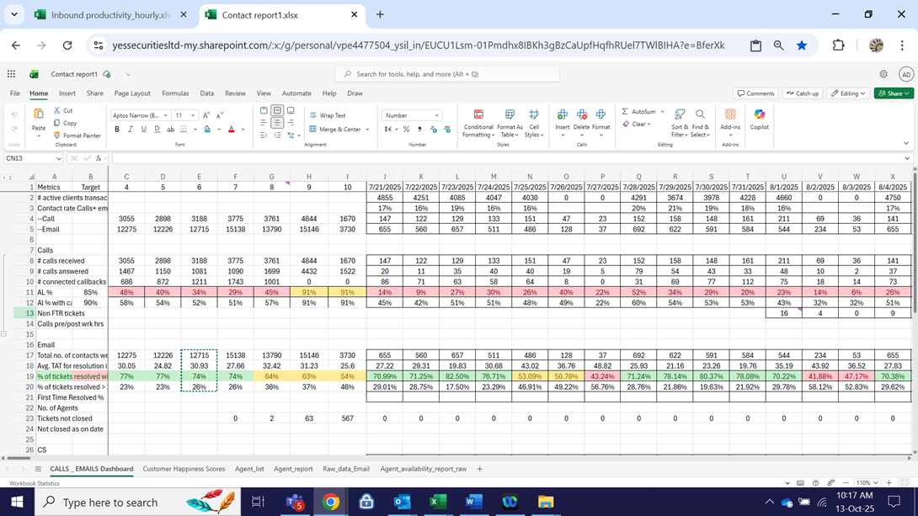
MIS shared with Management are as follows:
1. AMCOM data - Quarterly CS data is shared with the compliance team to be presented with the Apex committee of the Bank.
2. Board Meet slide – Quarterly CS data is shared with the management to present in the board meetings.
3. Council Meeting: Customer service review & customer pain areas to be discussed monthly with MD CEO.

